2. Describe the idea of the Access Based Enumaration (ABE) feature. Provide details and different scenarious.

Access-based enumeration (ABE) displays only the files and folders that a user has permissions to access. It is a feature that was previously available as a downloadable package for the Windows Server 2003(but included from SP1).
Access-based enumeration is now included in the Windows Server 2008, and you can enable it by using Share and Storage Management for the share were you want to enable it. For example, if you enable access-based enumeration on a shared folder that contains many users home directories, users who access the shared folder can see only their personal home directories; other users folders are hidden from view. This can also be used on shares such as common areas, application areas and so on.

Some quick information about ABE:

- ABE is not supported for use with DFS Namespaces to hide DFS links. However, ABE can be used with DFS to hide the files in the folders within the DFS Shares.

- ABE does not hide shares. ABE hides content in a share based on user access rights. When ABE is enabled on a share, a user will only see the content that they have access to in the share.

- ABE doesn't have effect on the users with the Backup files and folders right. Any user who has the Backup files and directories right will see all files in a shared directory. This is necessary so that backup programs can backup all files in the directory.

- The Users can view (but not modify) the contents of other user's folders to which they have no permissions if the files have been marked for Offline access and the workstation is removed from the network.

1. First we need to set the share and NTFS security settings right to get ABE to work:

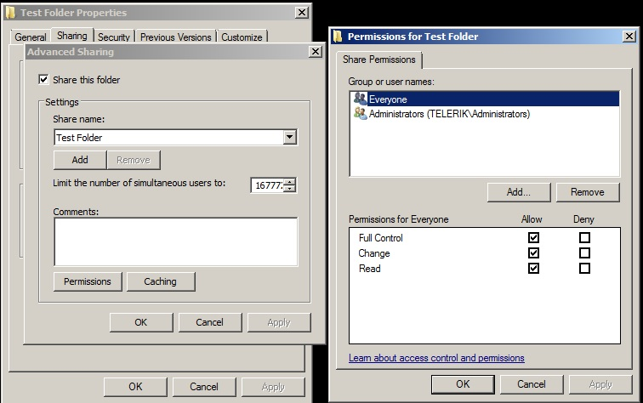

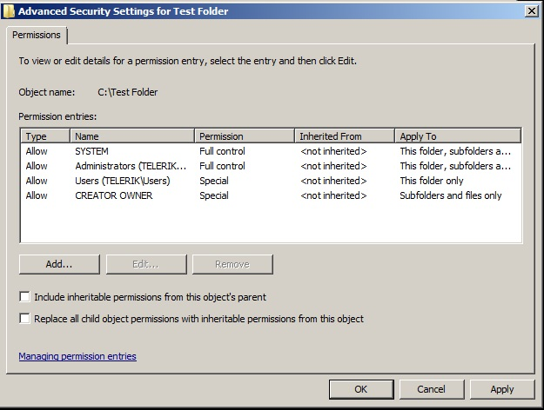

2. You need to activate ABE in both Share and Storage Management (Start Menu->Administrative Tools-> Share and Storage Management) and on your DFS namespace if you are running DFS. In Share and Storage Management we have to select Properties of the folder, that we choose to share with Right mouse button->Properties.
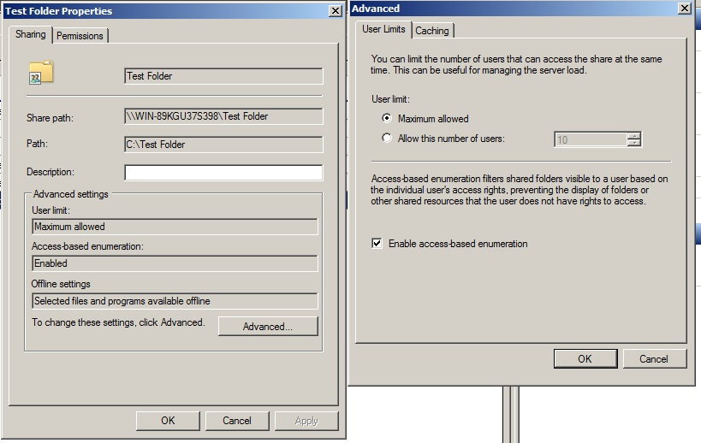

So when user is browsing the share where all home folders are listed it just shows the one it has access to – his own folder.

If a user with full access browses the same folder – it will show all folders in it.

